Web portal admin functions and reporting
Using the eKare inSight UK web portal gives you more options to manage your accounts, locations and users. It also gives you an overview of your patient data and enables you to export this data for analysis.

Visit www.ekare.ai to access the portal.

Select ‘LOGIN’ and then enter your inSight username and password:

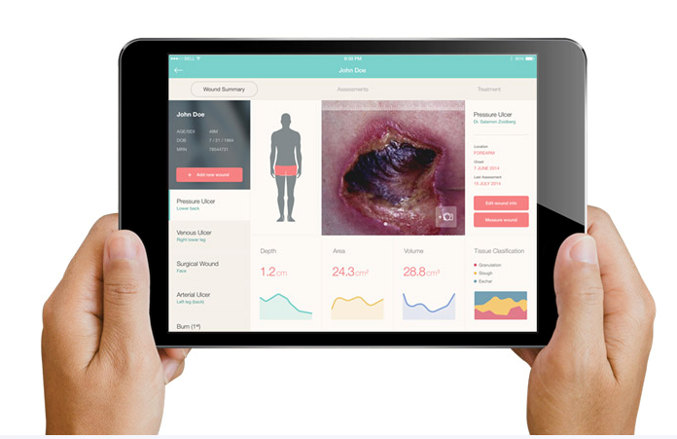
This guide will show you all the essentials you need to know to utilize inSight’s potential.

Contents
1| Managing sites 3
2| User management 3
2.1| Account level users 3
2.2| Site level users 4
3| Dashboard & Reports 5
3.1| Dashboards 5
3.2| Reports 5
4| Editing wounds/patients and troubleshooting 6
5| Field Management 7
5.1| Managing your fields 8

1| Managing sites
Sites are used to manage different locations. If your organization for example has multiple facility’s, setting up different sites for each of them helps you to keep a clean overview. Every account must have at least one site.
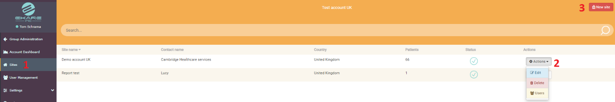
- Go to “Sites” on the menu bar on the left side of the screen.
- If you already have set up a site, you can edit this site by clicking on the “Actions” bar on the right side of the screen. This enables you to:

- Edit: Adjust the information of this site
- Delete: Erase this site entirely. This will also delete any patient the site has.
- Users: Changing the user’s active status or system role. To give a user access to a site simply click here and then check the ‘Active’ box next to the appropriate site.

- To create a new site, select the “New Site” button in the top right corner.
- Fill out all the information and click “Save” once everything is correct. Select “Create User” if you want to create a user directly after this step.
- Click on a site to enter this site. You’ll then land on the patient directory.

2| User management
User management enables you to edit existing users or add new ones. There are two levels to user management: account and site level.

2.1| Account level users
Creating an account user, gives this user access to all the sites that belong to this account. To select users on an account level, go to “User Management” in the menu bar before you’ve selected a specific site.
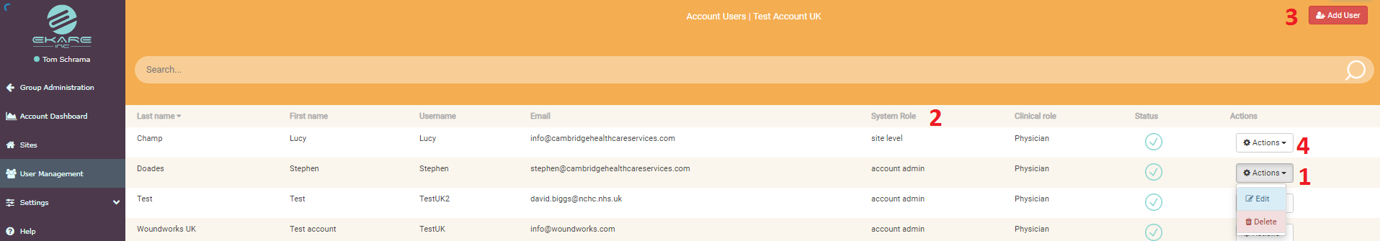
- You can edit account users by selecting the “Actions” bar for each user.
- System role indicates the type of rights the user has. As indicated in the image, one user is an account admin while the other only has access to a specific site.
- To add a new account user, select “Add user” in the top right corner. When filling out the information, you can choose between two system roles:

- Account viewer: Has unlimited access to everything in this account but can’t edit data
- Account Admin: Has unlimited access to everything in this account and is able edit any data and create users and sites.

- When clicking on the “Actions” bar next to a site level user, you can assign them to other sites as well.
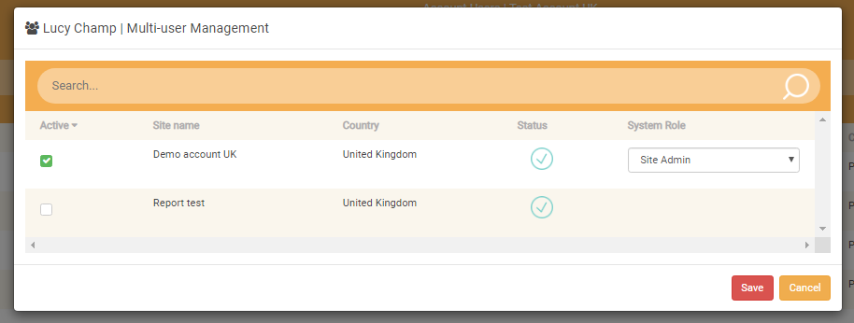

2.2| Site level users
Site level users only have access to the site you create them within, unless you give them access to other sites. This is the most common type of user you will currently need to set up or amend. To select users on a site level, first select a specific site through “Sites” in the menu bar. Then go to “User management” on the menu bar on the left side of the screen.
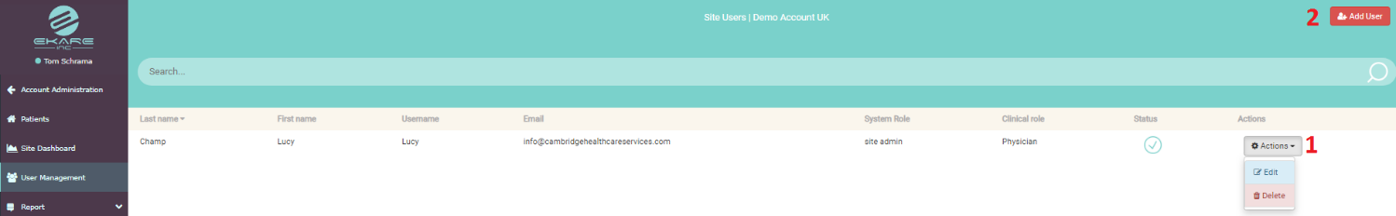
- To edit or delete existing users use the “Actions” bar on the right side of the screen.
- To create a user, select the “Add user” button
- When creating a user, you can select one of three system roles. These are:

- Site Viewer: Can’t edit any data but has access to all the information.
- Site User: Can edit patient information, log treatments and measurements.
- Site Admin: Can use inSight the same way as a Site User but also has the authority to edit site information, user information and create new users.

3| Dashboard & Reports
The dashboard gives you a quick overview of your patients and the wounds they have. If you have multiple sites, this information is combined in your account dashboard. For each individual site, there is a site dashboard.

3.1| Dashboards
Account Dashboard
When you’ve logged in your account, the landing page is your account dashboard. This, for example, shows you the number of patients, most common wound types and locations, and a breakdown for wound types and locations.
Site Dashboard
When you select one of your sites, the landing page is your patient directory. To view the dashboard based on the data for the site you’ve selected, go to “Site Dashboard” in the menu bar. This dashboard shows you the same graphs and charts as the account dashboard, but it visualizes the data of the selected site.

3.2| Reports
You can pull statistical data from the system via CSV download from either account or site admin menu screens as per the below. The data can only be exported on a site level. You’d have to manually combine this data outside of the eKare System.
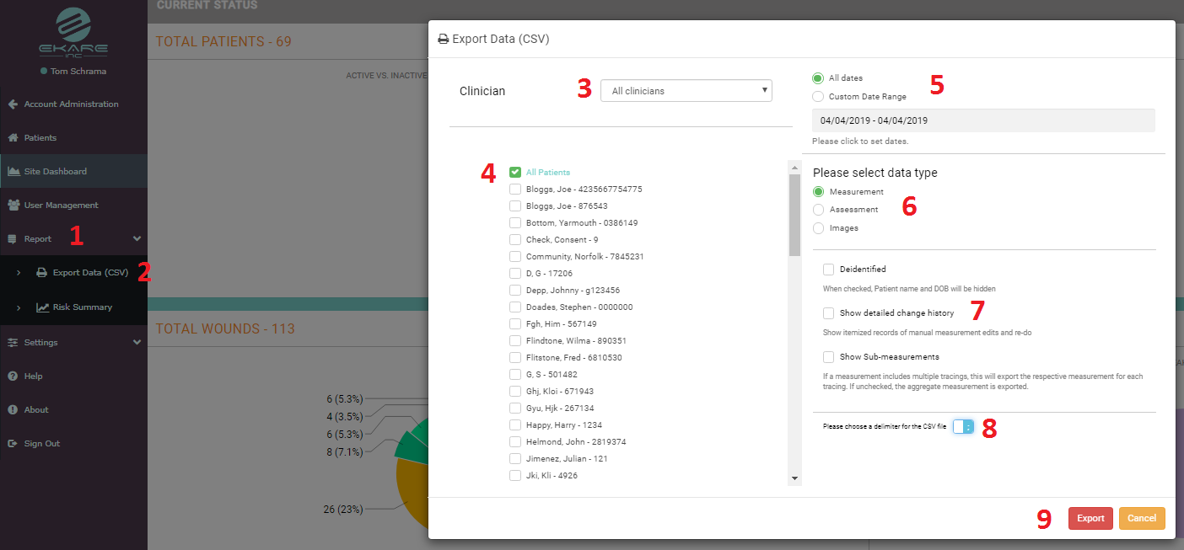
- Go to “Report” in the menu bar.
- Select “Export Data (CSV).
- Select whether you’d like an export for a specific clinician, or all the clinicians combined.
- Select if you’d want to export the data for all the patients, or individual patients.
- Select the data range. The option “All dates” gives you just today’s measurement. Use “Custom Date Ranges” to specify the right period.

- Select the type of data you’d like to export. You can select;
  - ‘measurement data’
  - ‘wound assessment data’
  - ‘images only’
- You can choose to anonymize the data, show detailed change history or show sub-measurements (e.g. when wounds are re-measured or edited). This is optional.
- Select the type of delimiter you’d like by sliding the switch. You can choose between.
- When all your settings are right, select “Export”.
- Depending on what you have chosen to export (the size and type of file) you will either see the report appear on your screen, or it will be emailed to the email address associated with your inSight log in, once it is ready. It should take a few seconds to a few minutes depending on your internet connection and report size.
Patient-specific reports can be pulled via PDF from the Patient home page (when on the web portal). This can include images, measurements, healing trajectory graphs and other information entered inSight.
See below;

4| Editing wounds/patients and troubleshooting
Deleting patients – If a patient has been created by mistake or is no longer required then people with admin level access can correct this. Press and hold the patient record on the main screen. You will then see the following;

To deactivate the patient, select ‘Freeze’. Data and images cannot be added, edited or deleted for frozen patients. You may wish to deactivate a patient if, for example, they are discharged or they move out of the area covered by your organisation. Please note, frozen patients are removed from view in the Patient Directory. To get them to appear, adjust filter settings so that ‘Active Patients Only’ is deselected.
Deleting/moving a wound image and measurement - If a wound image needs to be deleted or moved within the same patient, then admin users can do this. Simply click on the wound image from the patient home screen gallery. You can select from icons in white at the top right of the enlarged image screen depending on what you need to do.

5| Field Management
Although inSight gives you a lot of options when gathering your data and registering your treatments and assessments, it still might not be tailored to your specific needs. With “Field Management” you can alter a some of the options you can select while working on the iPad. Before explaining how to do this, a few examples are given.
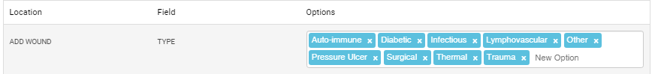

When adding a wound on the iPad, one of the questions is which type of wound it is. Using the example above, you’re adding a wound on the iPad and when selecting the type, you’re given a certain amount of option. The options are the “Tags” in blue. You can delete these and enter new options, using whatever your teams prefer.

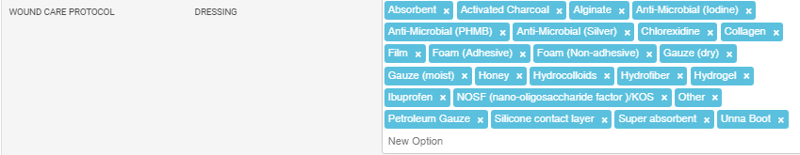

When registering your wound care protocol, you’re able to select types of dressing. Perhaps you prefer a specific brand within a category. You could add that by adding it to these options.

5.1| Managing your fields
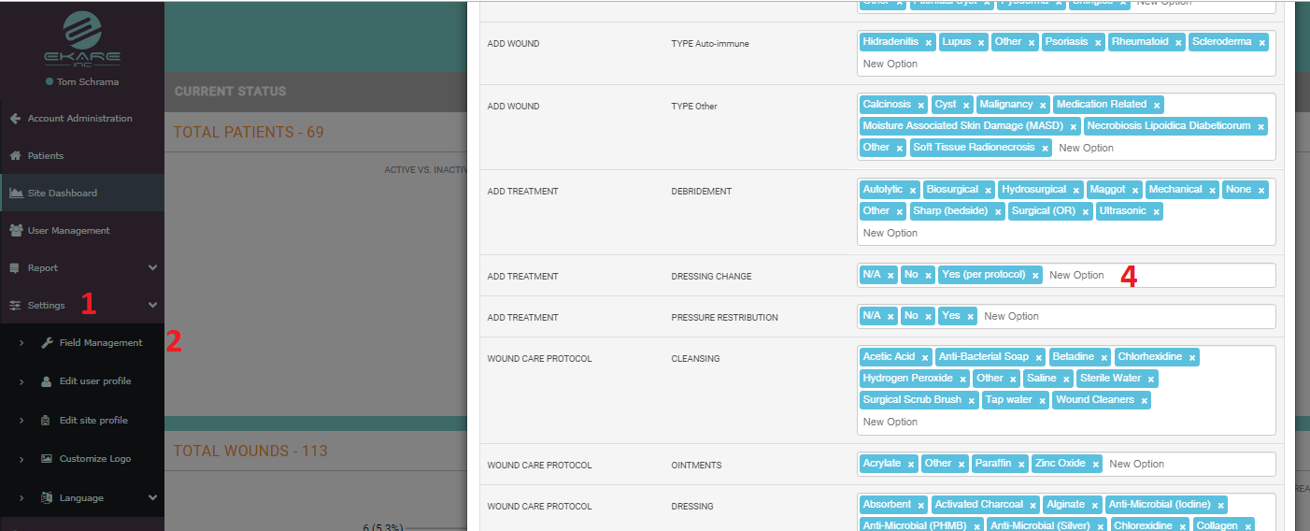
- Go to “Settings” in the menu bar.
- Then select “Field Management”.
- Look for the type of field of which you’d like to change the options.
- Select the field and start typing to add a new option. By hitting “Enter” you create a new tag.
- Hit “Backspace” or click on the cross within the tag to delete an existing tag.

